**/\* Write a query to display all appointments made by the patient with patientID 2200003 \*/**

SELECT \* FROM APPOINTMENT

WHERE PatientID = 2200003;

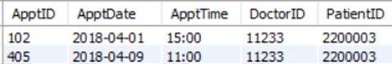

**/\*Write a query to display names of doctors and patients, doctors' specialism,**

**appointment' ID, date and time made by the patient with patientID 2200003\*/**

SELECT ApptID, ApptDate, ApptTime, PatientName, DoctorName, Speialism

FROM APPOINTMENT

JOIN DOCTOR on APPOINTMENT.DoctorID = DOCTOR.DoctorID

JOIN PATIENT on APPOINTMENT.PatientID = PATIENT.PatientID

WHERE APPOINTMENT.PatientID = 2200003;

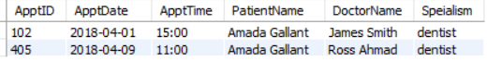

**/\*Write a query to display the names and phone of all patient and doctor**

**Assume that no patient is also a doctor. \*/**

SELECT 'Doctor' as Type, DoctorName, DoctorPhone

FROM DOCTOR

UNION

SELECT 'Patient', PatientName, PatientPhone

FROM PATIENT;

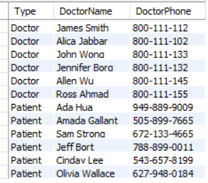

**/\*Write a query display the name of all doctor and the name of their supervisor\*/**

SELECT a.DoctorName, b.DoctorName as SupervisorName

FROM DOCTOR a

LEFT JOIN DOCTOR b ON a.DoctorID = b.SuperID;

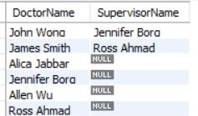

**/\*Write a query display the department number( from smallest to largest), department name,**

**doctor names, Speialism of all female doctors \*/**

SELECT DeptNo, DeptName, DoctorName, Speialism

FROM DEPARTMENT

LEFT JOIN DOCTOR ON DEPARTMENT.DeptNo = DOCTOR.DNo

WHERE DoctorSex = 'F'

ORDER BY DeptNo;

